**02. MIGRATION - MODEL**

1. Buka project “laract-penilaian-siswa”
2. Buka file .env -> setting nama database menjadi “penilaian-siswa”

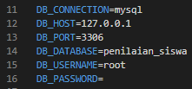

1. Buka terminal -> ketik syntax dibawah ini

“php artisan make:model Administrator -m”

“php artisan make:model Guru -m”

“php artisan make:model Siswa -m”

“php artisan make:model Jurusan -m”

“php artisan make:model Mapel -m”

“php artisan make:model Kelas -m”

“php artisan make:model Mengajar -m”

“php artisan make:model Nilai -m”

1. Setting field table pada file migration
2. File migration administrators

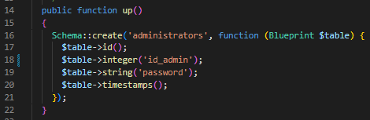

1. File migration gurus

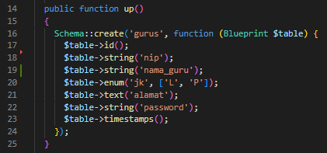

1. File migration siswas

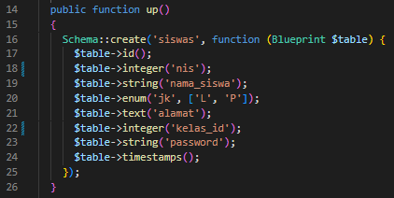

1. File migration jurusans

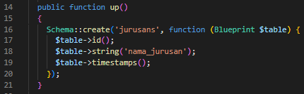

1. File migration mapels

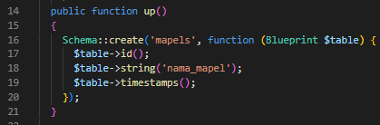

1. File migration kelas

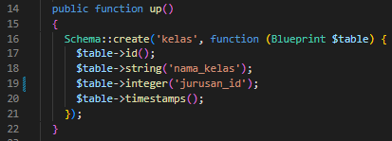

1. File migration mengajars

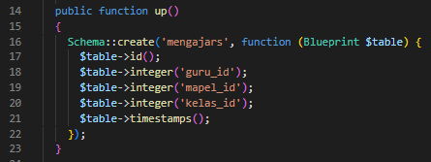

1. File migration nilais

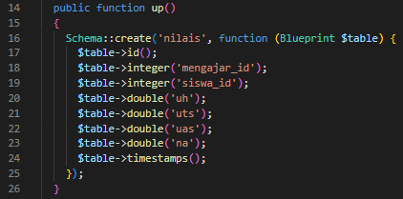

1. Setelah setting field pada file migration

Buka Terminal -> Ketik “php artisan migrate”

1. Setting relasi table pada file model
2. File model Administrator

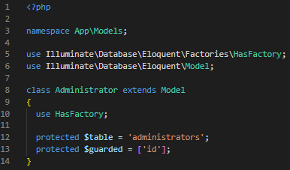

1. File Model Guru

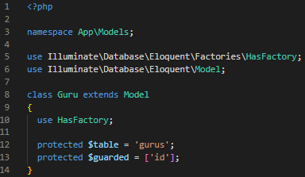

1. File Model Siswa

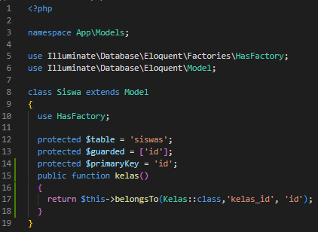

1. File Model Jurusan

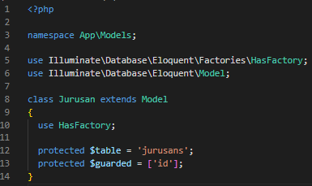

1. File Model Mapel

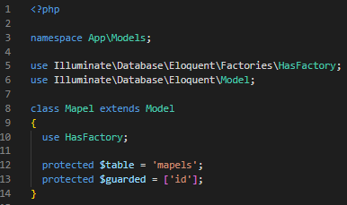

1. File Model Kelas

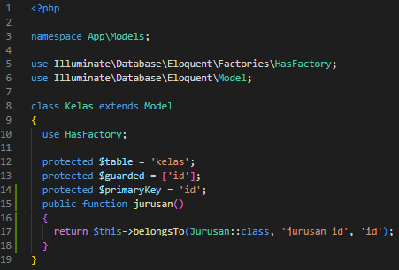

1. File Model Mengajar

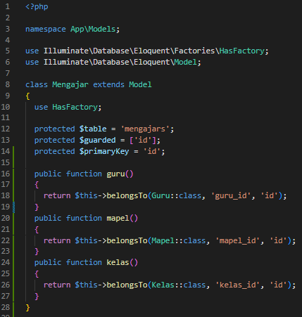

1. File Model Nilai

